Swiggy Data Analysis
Microsoft Fabric | SQL | Power BI
End-to-End Data Engineering & Analytics Portfolio Project

Platform | Microsoft Fabric (Lakehouse + Warehouse + Semantic Model + Power BI)

Domain | Food Delivery Analytics — Swiggy, India

Data Volume | ~197,000 Orders | 5 Tables | Star Schema | Jan–Aug 2025

Status | COMPLETE — Both Parts Delivered End-to-End

Skills Demonstrated | Fabric, Lakehouse, Data Pipelines, T-SQL, Semantic Model, Power BI DAX, Dashboard Design

Author | Student Project — Data Engineering & Analytics Track | March 2026

Amankumar Bhatu  Data Engineering & Analytics Track | March 2026 | CAPSTONE PROJECT  Microsoft Fabric | SQL | Power BI

Everything in this project was built hands-on — configured, tested, and validated from scratch using real cloud infrastructure.

Business Problem & Solution

The Problem
Swiggy operates across hundreds of Indian cities, processing hundreds of thousands of food orders every month across thousands of restaurants and cuisine types. Despite the scale of this data, the business had no centralised, structured way to answer the questions that matter most to operations, marketing, and restaurant partnerships:

- Which cities and states are generating the most revenue — and which are underperforming?
- Which restaurant chains are the highest earners on the platform?
- Is demand growing or declining month by month? Are there seasonal patterns?
- Do customers prefer veg or non-veg food, and how does that affect total sales?
- Which days of the week and weeks of the year see the most orders?
- What is the average order value, and how does it compare across segments?

Without a structured data pipeline and a reporting layer, answering any of these questions required manually exporting raw CSVs, running ad-hoc queries, and producing one-off reports — time-consuming, inconsistent, and impossible to share at scale with business stakeholders.

Pain Point | Business Impact
Raw order data spread across multiple CSV files with no single source of truth | No reliable way to produce consistent business reports
Date column stored as plain text — unusable for time-based analysis (monthly trends, weekly patterns) | Time intelligence reports were impossible without manual data fixes
No star schema or data model — tables not connected to each other | Could not slice revenue by restaurant, city, food type, or time simultaneously
No self-service reporting layer — analysts needed raw data access to answer any question | Business stakeholders dependent on technical team for every insight
No published, shareable dashboard — insights locked in local files | Leadership could not access live performance data from a browser or mobile device

The Solution
As the data analyst on this project, Amankumar Bhatu designed and built a complete end-to-end analytics pipeline on Microsoft Fabric — eliminating every pain point listed above and delivering a live, interactive dashboard that any stakeholder can access from a browser with no technical knowledge required.

Problem | Solution Delivered | Fabric Component Used
Scattered raw CSV files | All 5 source files ingested into a centralised Lakehouse with a single pipeline | Fabric Lakehouse + Data Pipeline
Date column stored as text | ALTER TABLE + TRY_CONVERT(DATE, order_date, 5) applied — 100% data integrity confirmed via NULL check | Fabric Warehouse (T-SQL)
No data model or relationships | Star schema built: 1 fact table + 4 dimension tables with 4 active one-to-many relationships | Power BI Semantic Model (DirectQuery)
No self-service reporting | 8-visual interactive dashboard with 4 slicers — filter by city, food type, quarter, restaurant with zero SQL knowledge | Power BI Desktop + DAX
No shareable dashboard | Report published to Fabric workspace — accessible live via browser, exportable as PDF | Fabric Workspace (Published Report)

Outcomes Delivered
The final dashboard answers 6 core business questions in real time — with zero SQL required from the end user.

Business Question | Answer from Dashboard
What is total platform revenue? | ₹53.01M across 197,430 orders (Jan–Aug 2025)
What is the average spend per order? | ₹268.51 average order value
Which state is the top market? | Karnataka — ₹5.5M, nearly double the second-placed state
Which restaurant chain leads sales? | KFC at ₹4.2M, followed by McDonald's (₹3.3M) and Pizza Hut (₹2.1M)
What is the veg/non-veg sales split? | 63.7% Veg (₹33.77M) vs 36.3% Non-Veg (₹19.24M)
When is demand highest? | Saturday is peak day; May and August are peak months at ₹6.79M each

Executive Summary
This project delivers a complete, production-style business intelligence pipeline for Swiggy — one of India's largest food delivery platforms — built entirely on Microsoft Fabric. It covers every stage of the modern data stack: raw data ingestion, Delta table conversion, SQL-based data cleaning, star-schema warehouse modelling, automated pipeline orchestration, semantic model publication, and a fully interactive Power BI dashboard published to a live Fabric workspace.

Project Stage | Technology Used | Output
Raw Data Ingestion | Fabric Lakehouse (OneLake) | 5 CSV files loaded into Files section
Delta Table Conversion | Fabric Pipelines + PySpark (ADLS Gen2) | 5 validated Delta/Parquet tables in Lakehouse
Data Cleaning | T-SQL in Fabric Data Warehouse | order_date column converted to DATE type via ALTER + TRY_CONVERT
Warehouse Modelling | Fabric Warehouse (T-SQL, swiggy_project schema) | Star schema with 1 fact + 4 dimension tables
Semantic Model | Power BI connected to Fabric Warehouse (DirectQuery) | Published model in Fabric workspace with 4 active relationships
Dashboard & Reporting | Power BI Desktop + DAX measures | 8-visual interactive dashboard published to Fabric workspace

Dashboard Headline Numbers — 197,430 Orders | ₹53.01M Total Sales | ₹268.51 Avg Order Value | 4.34 Avg Rating

Solution Architecture

Medallion Architecture on Microsoft Fabric
The project follows a three-layer medallion architecture — an industry-standard pattern used by enterprise data teams — implemented entirely within one Fabric workspace.

Layer | Fabric Component | Data State | What Happens Here
Bronze | Swiggy_lw (Files) | Raw, unprocessed | CSV files uploaded as-is — no transformation
Silver | Swiggy_lw (Tables) | Structured Delta/Parquet | Files converted to ACID-compliant tables via pipelines
Gold | swiggy_dw (Warehouse) | Cleaned, modelled, query-ready | SQL data cleaning + star schema for reporting

Workspace Components
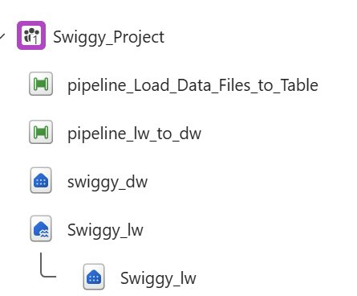
Fig 1 — Swiggy_Project workspace: 2 pipelines, 1 Lakehouse, 1 Data Warehouse

Component | Type | Role
Swiggy_lw | Lakehouse | Bronze + Silver layer storage. Raw CSV files and converted Delta tables
swiggy_dw | Data Warehouse | Gold layer. swiggy_project schema with all 5 cleaned and modelled tables
pipeline_Load_Data_Files_to_Table | Data Pipeline | Converts CSV files → Delta tables inside the Lakehouse
pipeline_lw_to_dw | Data Pipeline | Migrates all 5 tables from Lakehouse → Warehouse in parallel

PART 1 — Data Engineering Pipeline

Lakehouse Setup & Data Ingestion
A Fabric Lakehouse (Swiggy_lw) was created and all five raw CSV source files were uploaded into its Files section — the bronze layer. The Files section accepts any file format, making it suitable for unstructured or semi-structured raw data before any processing occurs.

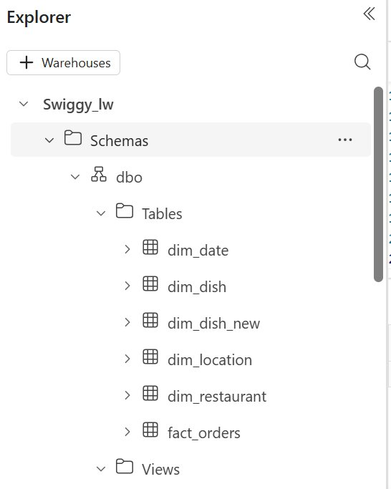  Fig 2 — Lakehouse Delta tables after CSV conversion | 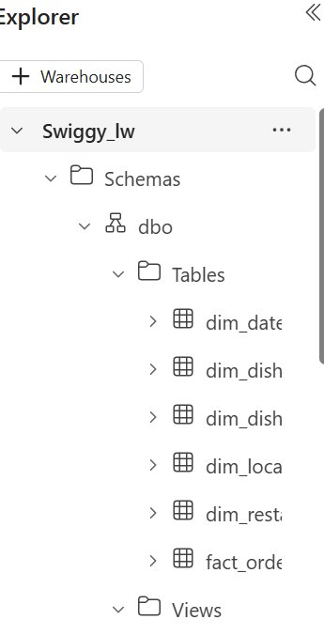  Fig 3 — Lakehouse SQL endpoint schema explorer

Each CSV file was converted from raw format into Delta/Parquet (park) format via Copy Data pipeline activities — invoking PySpark under the hood. Delta tables have ACID properties (Atomicity, Consistency, Isolation, Durability), making them reliable for downstream analytical workloads. Once in Tables, the built-in SQL Analytics Endpoint was used to validate record counts with T-SQL queries before any data moved to the warehouse.

Pipeline: Lakehouse → Data Warehouse
A second pipeline (pipeline_lw_to_dw) was built with 5 parallel Copy Data activities — one per table. Each activity reads from the Lakehouse Delta table and writes into the swiggy_project schema of the warehouse, using Azure Data Lake Storage Gen2 as the transfer engine.

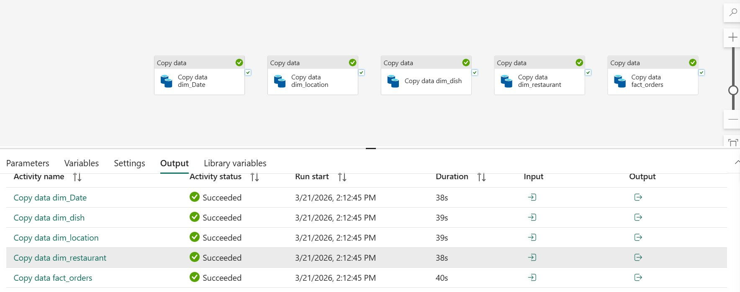
Fig 4 — pipeline_lw_to_dw: all 5 Copy Data activities succeeded in a single parallel run

Activity | Status | Duration | Records
Copy data dim_Date | ✓ Succeeded | 38s | 243
Copy data dim_dish | ✓ Succeeded | 39s | 8,891
Copy data dim_location | ✓ Succeeded | 39s | 995
Copy data dim_restaurant | ✓ Succeeded | 38s | 993
Copy data fact_orders | ✓ Succeeded | 40s | 197,430

PART 2 — Data Cleaning, Semantic Model & Power BI Dashboard

Data Cleaning — SQL in the Warehouse

Data Type Validation
Before building the semantic model, all table columns were validated for correct data types using the Warehouse SQL endpoint. A critical issue was found: the order_date column in dim_date was stored as a STRING (ABC type) — imported as text from the original CSV. All ID columns across all tables were confirmed as INTEGER, which is required for relationship joins to work correctly in Power BI.

Table | Column | Original Type | Issue Found | Resolution
dim_date | order_date | String (ABC) | Date stored as text — unusable for time intelligence | New column order_date_new created as DATE type
dim_date | date_id | Integer | None | No action required
fact_orders | All ID columns | Integer | None | Confirmed match with dimension PKs
dim_dish | dish_id | Integer | None | Matches food_id in fact_orders
dim_location | location_id | Integer | None | No action required
dim_restaurant | restaurant_id | Integer | None | No action required

SQL Data Fix — ALTER TABLE + TRY_CONVERT
Because warehouse tables cannot have existing columns altered directly, a new column was added to hold the correctly typed date, then populated using TRY_CONVERT with style code 5 (matching the source dd-mm-yyyy format). A final NULL check confirmed zero data loss.

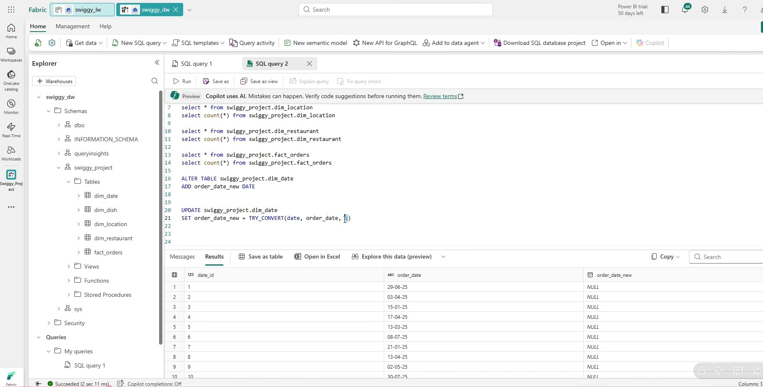
Fig 5 — swiggy_dw warehouse: ALTER TABLE and UPDATE TRY_CONVERT queries used to fix the order_date data type issue

-- Step 1: Add a new DATE column to the dim_date table
ALTER TABLE swiggy_project.dim_date
ADD order_date_new DATE;

-- Step 2: Populate it by converting the string date (dd-mm-yyyy = style 5)
UPDATE swiggy_project.dim_date
SET order_date_new = TRY_CONVERT(DATE, order_date, 5);

-- Step 3: Validate — confirm zero NULLs in the new column
SELECT * FROM swiggy_project.dim_date
WHERE order_date_new IS NULL;
-- Result: 0 rows returned — all 243 dates converted successfully

Why this matters: TRY_CONVERT with style 5 maps the exact source format (dd-mm-yyyy). Any unmatched rows return NULL — the zero-null result proved 100% data integrity.

Semantic Model — Power BI Connected to Fabric

Connection Method
Power BI Desktop was connected to the Fabric Warehouse via OneLake (DirectQuery mode). After connecting, the session was switched from Live Connection to Local Model mode — this unlocks the ability to create new calculated columns and measures using DAX, which is required for time intelligence fields like month, day, week number, and quarter.

Star Schema Relationships
Four active one-to-many relationships were configured in the semantic model, connecting fact_orders (many side) to each dimension table (one side) via their shared ID columns.

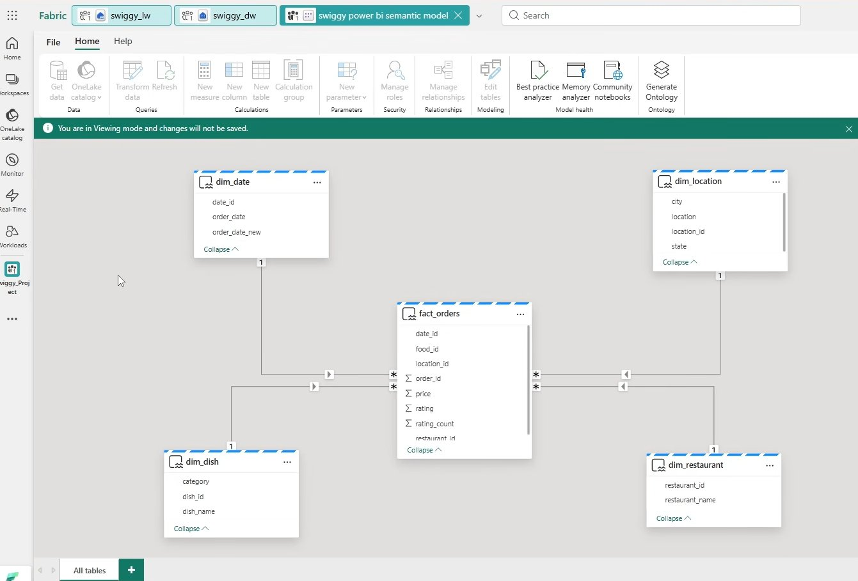
Fig 6 — Fabric semantic model (swiggy power bi semantic model) showing the star schema with all 4 active relationships

Relationship | Fact Column | Dimension Column | Type | Status
fact_orders → dim_date | date_id | date_id | Many to One | Active
fact_orders → dim_dish | food_id | dish_id | Many to One | Active
fact_orders → dim_location | location_id | location_id | Many to One | Active
fact_orders → dim_restaurant | restaurant_id | restaurant_id | Many to One | Active

The completed semantic model was published directly to the Fabric workspace (Swiggy_Project), making it available for report building without any manual export or file transfer step.

DAX Measures & Calculated Columns

Calculated Measures
Five DAX measures were created to drive the KPI cards on the dashboard:

Total Sales = SUM(fact_orders[price])

Total Orders = COUNT(fact_orders[order_id])

Avg Order Value = [Total Sales] / [Total Orders]

Avg Rating = AVERAGE(fact_orders[rating])

Rating Count = SUM(fact_orders[rating_count])

Calculated Columns (Time Intelligence)
Five new columns were added to dim_date to support time-series analysis. All calculations use order_date_new (the cleaned DATE column) — not order_date — to ensure correct data type handling:

-- Month name (abbreviated: Jan, Feb, Mar...)
Month = FORMAT(dim_date[order_date_new], "MMM")

-- Month number for correct calendar sort order
Month Number = MONTH(dim_date[order_date_new])
-- Month column sorted by Month Number ascending

-- Day name (abbreviated: Mon, Tue...)
Day = FORMAT(dim_date[order_date_new], "DDD")

-- Day number for Sun=1 to Sat=7 sort order
Day Number = WEEKDAY(dim_date[order_date_new], 1)

-- Week number in the year (1–52)
Week Number = WEEKNUM(dim_date[order_date_new])

-- Quarter (Q1, Q2, Q3, Q4)
Quarter = "Q" & QUARTER(dim_date[order_date_new])

Veg / Non-Veg Classification
A calculated column was added to dim_dish to classify dishes as Veg or Non-Veg, using keyword matching on dish names (e.g., chicken, mutton, egg, fish). This enabled the donut chart breakdown by food type on the dashboard:

Food Type =
IF(
CONTAINSSTRING(LOWER(dim_dish[dish_name]), "chicken") ||
CONTAINSSTRING(LOWER(dim_dish[dish_name]), "mutton") ||
CONTAINSSTRING(LOWER(dim_dish[dish_name]), "egg") ||
CONTAINSSTRING(LOWER(dim_dish[dish_name]), "fish") ||
CONTAINSSTRING(LOWER(dim_dish[dish_name]), "prawn"),
"Non-Veg", "Veg"
)

Power BI Dashboard
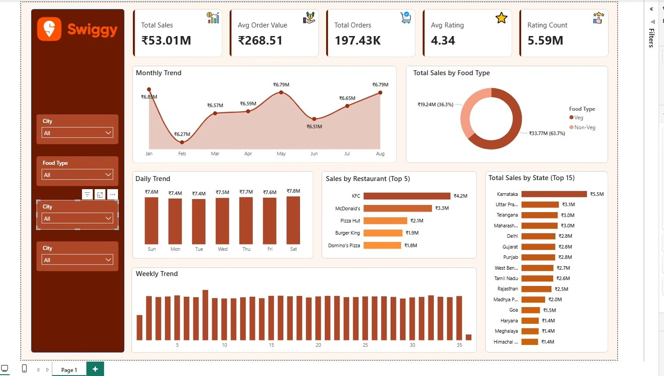
Fig 7 — Final Swiggy Analytics dashboard published to Fabric workspace (swiggy_power_bi_semantic_model)

Dashboard Components
Visual | Type | Dimensions Used | Metric | Business Question Answered
5 KPI Cards | Card | — | Total Sales, Avg Order Value, Total Orders, Avg Rating, Rating Count | What is the overall business performance?
Monthly Trend | Area Chart | Month (dim_date) | Total Sales | How does revenue vary month by month?
Daily Trend | Column Chart | Day (dim_date) | Total Sales | Which day of the week drives the most orders?
Weekly Trend | Column Chart | Week Number (dim_date) | Total Sales | How does performance shift across the calendar year?
Sales by Food Type | Donut Chart | Food Type (dim_dish) | Total Sales | What share of revenue comes from Veg vs Non-Veg?
Sales by Restaurant (Top 5) | Bar Chart + Gradient | Restaurant Name (dim_restaurant) | Total Sales | Which restaurant chains generate the most revenue?
Sales by State (Top 15) | Bar Chart + Gradient | State (dim_location) | Total Sales | Which states are the highest-performing markets?
4 Slicers | Dropdown Slicers | City, Food Type, Quarter, Restaurant | — | Filter entire dashboard by any dimension

Key Findings from the Dashboard
- Total revenue across 197,430 orders reached ₹53.01M for Jan–Aug 2025 with an average order value of ₹268.51
- Karnataka is the highest-revenue state at ₹5.5M, followed by Uttar Pradesh (₹3.1M) and Telangana (₹3.0M)
- KFC leads restaurant sales at ₹4.2M, followed by McDonald's (₹3.3M) and Pizza Hut (₹2.1M)
- 63.7% of all sales come from Veg food types — a significant split worth highlighting for restaurant partners
- Saturday is the peak order day; May and August show the highest monthly revenue at ₹6.79M each
- Average customer rating is 4.34 with 5.59M total rating interactions — indicating high engagement

Full SQL Reference

Lakehouse SQL Endpoint — Record Count Validation
-- Validate all 5 tables after CSV → Delta conversion
SELECT * FROM dim_date; SELECT COUNT(*) FROM dim_date; -- 243
SELECT * FROM dim_dish; SELECT COUNT(*) FROM dim_dish; -- 8,891
SELECT * FROM dim_location; SELECT COUNT(*) FROM dim_location; -- 995
SELECT * FROM dim_restaurant; SELECT COUNT(*) FROM dim_restaurant; -- 993
SELECT * FROM fact_orders; SELECT COUNT(*) FROM fact_orders; -- 197,430

Warehouse — Schema Creation + Table Validation
-- Create the project schema
CREATE SCHEMA swiggy_project;

-- Validate all 5 tables after Lakehouse → Warehouse pipeline
SELECT * FROM swiggy_project.dim_date; SELECT COUNT(*) FROM swiggy_project.dim_date; -- 243
SELECT * FROM swiggy_project.dim_dish; SELECT COUNT(*) FROM swiggy_project.dim_dish; -- 8,891
SELECT * FROM swiggy_project.dim_location; SELECT COUNT(*) FROM swiggy_project.dim_location; -- 995
SELECT * FROM swiggy_project.dim_restaurant; SELECT COUNT(*) FROM swiggy_project.dim_restaurant; -- 993
SELECT * FROM swiggy_project.fact_orders; SELECT COUNT(*) FROM swiggy_project.fact_orders; -- 197,430

Warehouse — Data Cleaning Queries
-- Add new DATE column (existing string column cannot be altered directly)
ALTER TABLE swiggy_project.dim_date
ADD order_date_new DATE;

-- Populate it: TRY_CONVERT style 5 = dd-mm-yyyy format
UPDATE swiggy_project.dim_date
SET order_date_new = TRY_CONVERT(DATE, order_date, 5);

-- Null check — confirm zero data loss after conversion
SELECT * FROM swiggy_project.dim_date WHERE order_date_new IS NULL;
-- Expected result: 0 rows

Microsoft Fabric Skills Demonstrated
This table maps each Fabric capability to the exact task performed in this project:

Fabric Capability | What Was Done | Where
Workspace & Capacity Management | Created and managed Swiggy_Project workspace with Fabric trial capacity | Fabric Portal
Lakehouse (OneLake) | Uploaded raw CSV files, converted to ACID-compliant Delta/Parquet tables | Swiggy_lw
SQL Analytics Endpoint | Validated record counts and data types via T-SQL without leaving Fabric | Swiggy_lw SQL endpoint
Data Pipelines (Data Factory) | Built 2 pipelines with 5 parallel Copy Data activities; used ADLS Gen2 engine | pipeline_lw_to_dw
Data Warehouse (T-SQL) | Created schema; ran schema-qualified queries; performed ALTER TABLE + UPDATE for data cleaning | swiggy_dw
Medallion Architecture | Applied Bronze/Silver/Gold layering — Files → Tables → Warehouse schema | Full pipeline
DirectQuery / Semantic Model | Connected Power BI to Fabric Warehouse via DirectQuery; published semantic model to workspace | Power BI + Fabric
DAX (Measures + Columns) | Wrote 5 KPI measures and 6 calculated columns for time intelligence and classification | Power BI semantic model
Star Schema Design | Configured 4 one-to-many relationships between fact and dimension tables | Semantic model
Power BI Dashboard Design | Built 8-visual dashboard with KPIs, trend charts, top-N bar charts, slicers | Power BI Desktop
Report Publishing to Fabric | Published completed .pbix report to Fabric workspace; accessible live via browser | Fabric workspace

